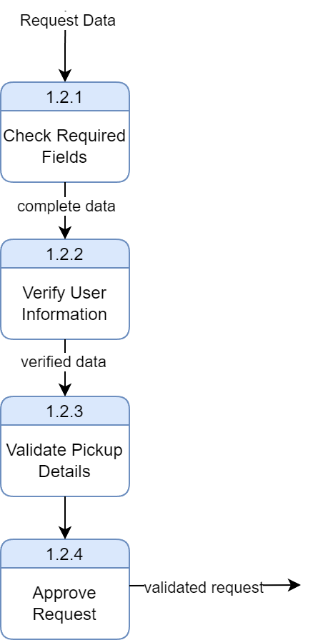
DFD Level 2- Recycling Pickup Schedule
DFD Level 2 further decomposes the “1.2 Validate Request” process into smaller internal steps. It shows how the system checks required fields, verifies user information, validates pickup details, and finally produces a validated request.

